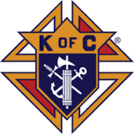
Dr. Anthony Vento
150 N. 3rd Street, #304
Steubenville, Ohio 43952
DrAnthonyVento@Yahoo.com
(929) 403-2780

Subject: Solicitation for Donations to Support the Steubenville Community
Dear To Whomever This May Concern,
I hope this letter finds you in good health and high spirits. I am writing to you on behalf of Saint Norbert Media, Inc, a 501(c)(3) nonprofit organization, in conjunction with the Knights of Columbus Saint John Neumann Council #11828. We are reaching out to local businesses like yours to seek your support in our mission to uplift and empower the Steubenville community.
Saint Norbert Media, Inc is dedicated to promoting education, culture, and community development through various initiatives. One of our key projects is organizing pancake breakfasts in collaboration with the Knights of Columbus Saint John Neumann Council. These breakfasts serve as a platform to bring the community together and raise funds for important causes that benefit the local residents.
We are humbly requesting your support in the form of provisions, goods, or monetary donations to ensure the success of our pancake breakfasts and the impact they have on the Steubenville community. Your contribution will directly benefit local families in need, support educational programs, and provide resources for community development projects.
By donating provisions such as food items, beverages, or utensils, you will help us provide a delightful and memorable experience for the attendees of our pancake breakfasts. Your generous contribution will not only showcase your commitment to the community but also promote your business to a wide audience of local residents and supporters.
Alternatively, a monetary donation would greatly assist us in covering the costs associated with organizing these events, including venue rental, marketing, and purchasing essential supplies. Your financial support will enable us to maximize the impact of our initiatives and make a significant difference in the lives of those who need it most.
We understand that businesses receive numerous donation requests, and we appreciate your consideration of our cause. Any contribution, big or small, will be highly valued and acknowledged. As a token of our gratitude, we will prominently display your business name and logo at our pancake breakfast events, recognizing your generosity and commitment to the Steubenville community.
To discuss the details of your donation or explore other ways in which you can support our cause, please feel free to contact me at [929-403-2780] or [DrAnthonyVento@Yahoo.com]. I would be delighted to answer any questions you may have and provide additional information about our organization and the impact your contribution will have.
Thank you for taking the time to consider our request. Together, we can make a positive difference in the lives of the Steubenville community members and create a brighter future for all. We look forward to your favorable response and partnership in this noble endeavor.

With heartfelt gratitude,
Dr. Anthony Vento
President
Saint Norbert Media, Inc
501(c)(3) Nonprofit Organization
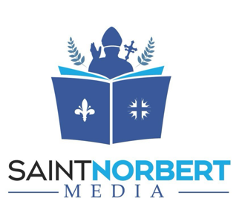
www.SaltLightLeaven.com

